Task 2: Data Visualization
Dataset: Iris Dataset
Objective:
Visualize patterns in dataset
Tasks:
- Create:
  - Bar chart
  - Histogram
  - Scatter plot
- Compare features
import seaborn as sns
import pandas as pd
df = sns.load_dataset("iris")
df.head()
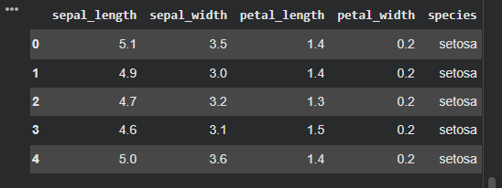

df.info()
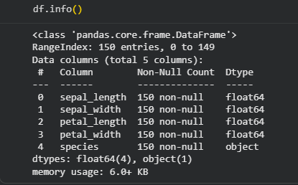

df.isnull().sum()
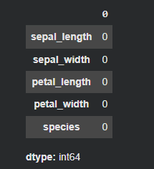

import matplotlib.pyplot as plt
df.groupby("species")["petal_length"].mean().plot(kind="bar")
plt.title("Average Petal Length by Species")
plt.xlabel("Species")
plt.ylabel("Average Petal Length")
plt.xticks(rotation=0)
plt.show()

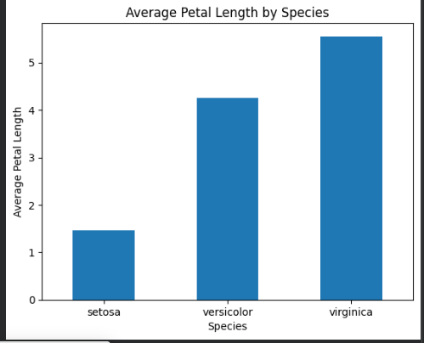

plt.hist(df["sepal_length"], bins=10)
plt.title("Distribution of Sepal Length")
plt.xlabel("Sepal Length")
plt.ylabel("Frequency")
plt.show()
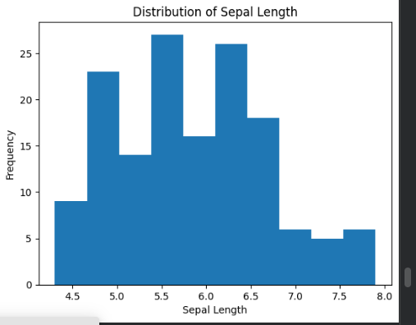

plt.scatter(df["sepal_length"], df["petal_length"])
plt.title("Sepal Length vs Petal Length")
plt.xlabel("Sepal Length")
plt.ylabel("Petal Length")
plt.show()
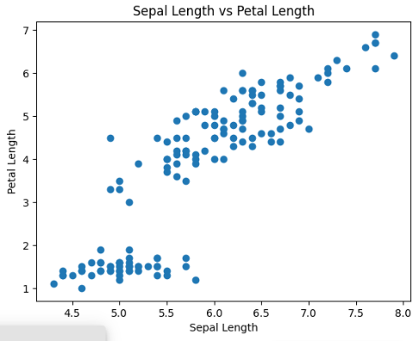

df.groupby("species")[[
"sepal_length",
"sepal_width",
"petal_length",
"petal_width"
]].mean()

